**Cloud Security Assignment 1: Create a Container in OwlCloud**

**Name: Naga Prem Sai Nellure  
 mail id:** [**nnellure2022@fau.edu**](mailto:nnellure2022@fau.edu) **Professor name: Rhian Resnick**

1. Gitlab login page  
   <https://gitlab.hpc.fau.edu/>

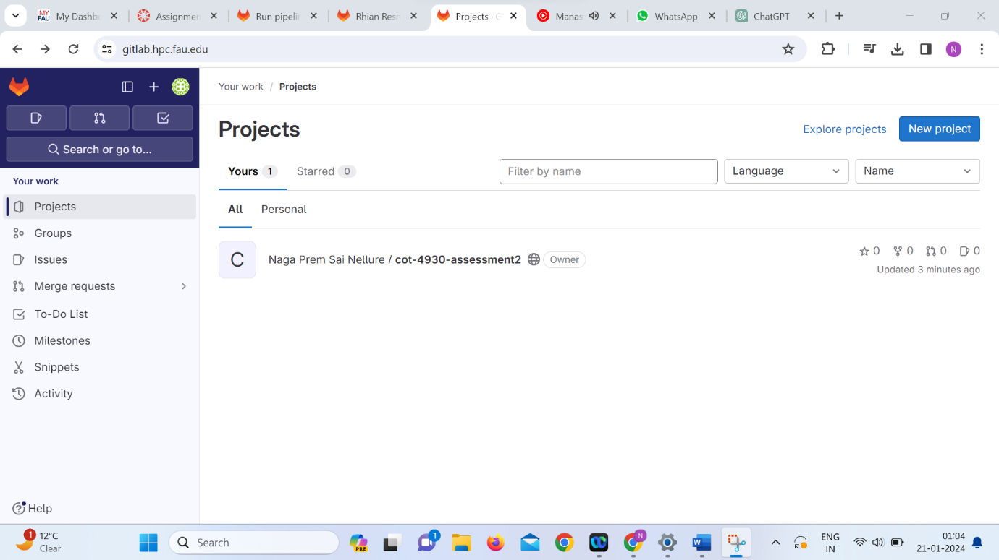

1. Pipelines  
   <https://gitlab.hpc.fau.edu/nnellure2022/cot-4930-assessment2/-/pipelines>

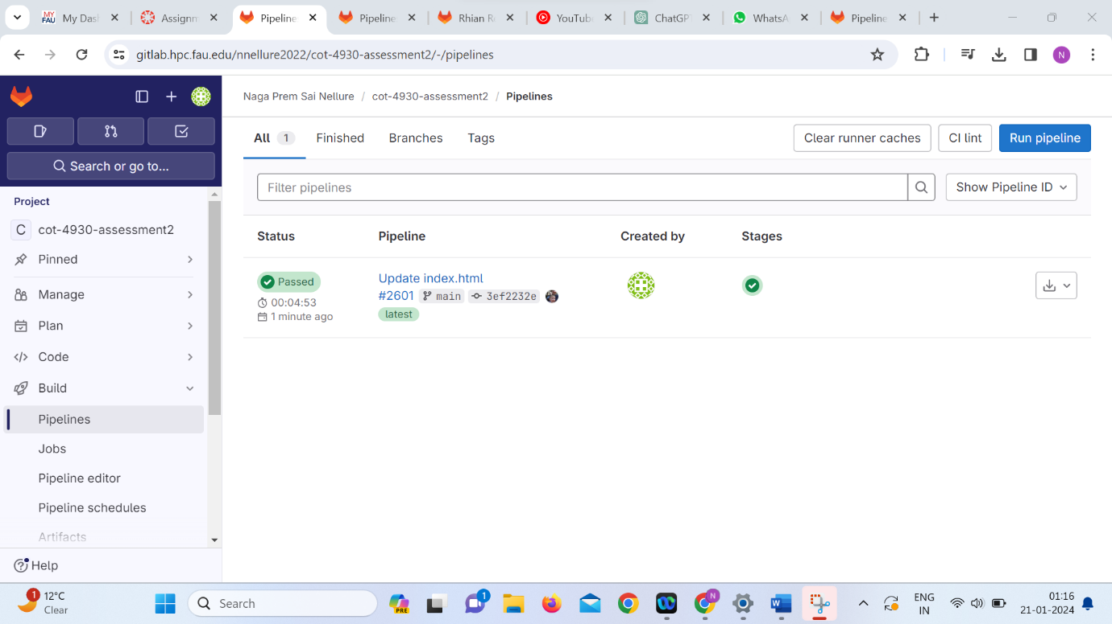

1. Container registry  
   <https://gitlab.hpc.fau.edu/nnellure2022/cot-4930-assessment2/container_registry>  
   registry.hpc.fau.edu/nnellure2022/cot-4930-assessment2  
     
   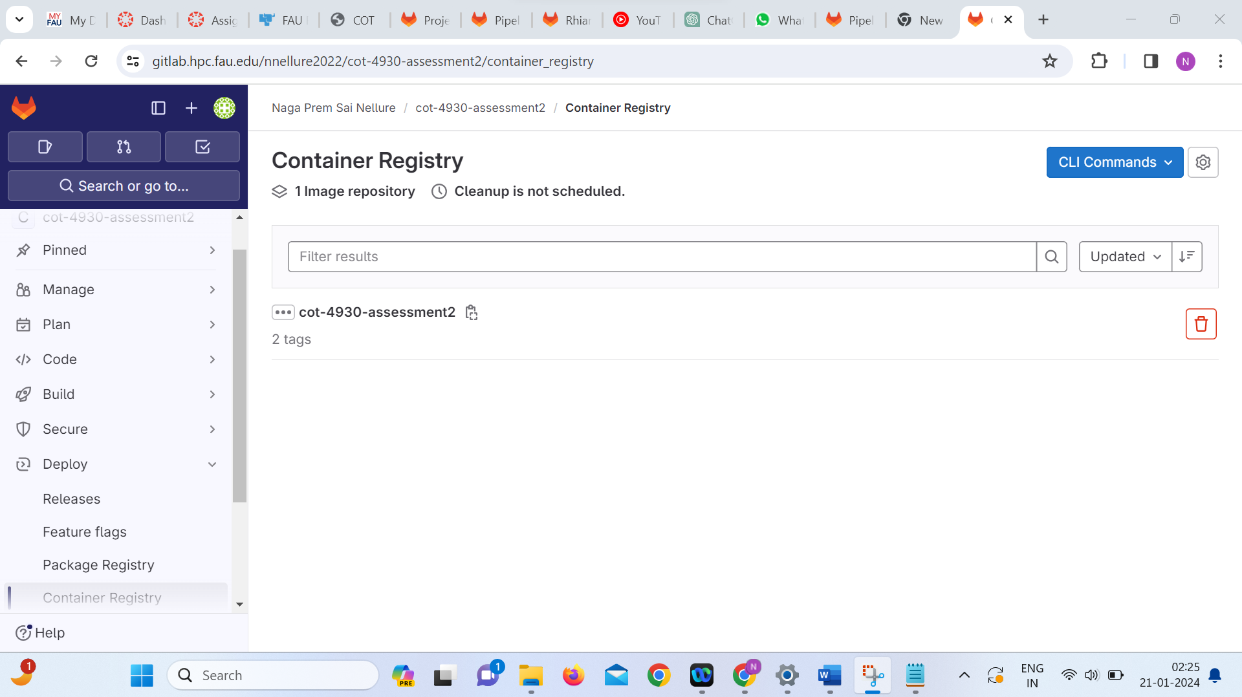
2. Project namespace  
   <https://jup19rancher.hpc.fau.edu/dashboard/c/c-m-hb7m6zzm/explorer/projectsnamespaces>  
     
   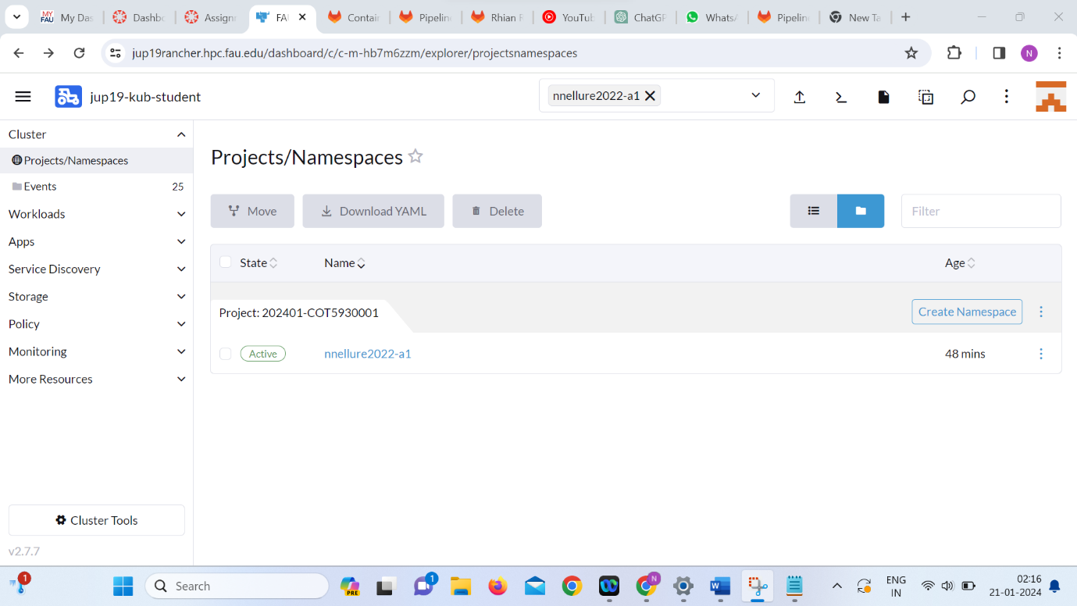

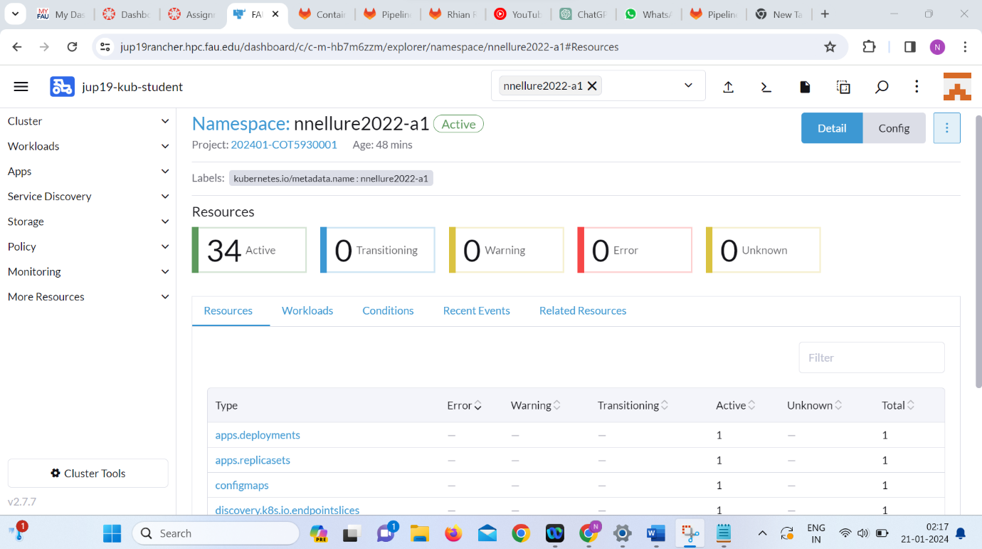

1. Deployment  
   <https://jup19rancher.hpc.fau.edu/dashboard/c/c-m-hb7m6zzm/explorer/apps.deployment>

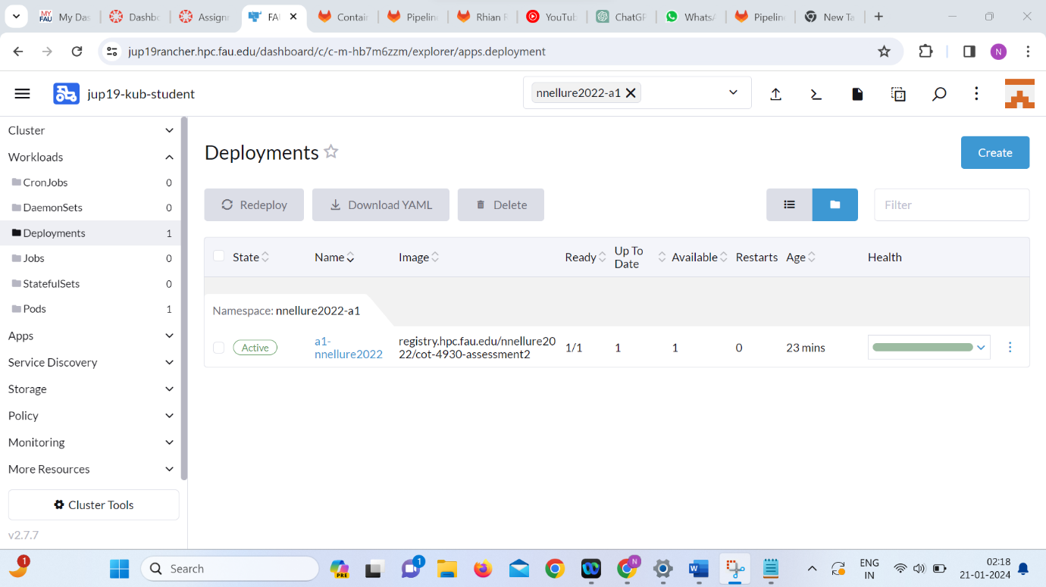

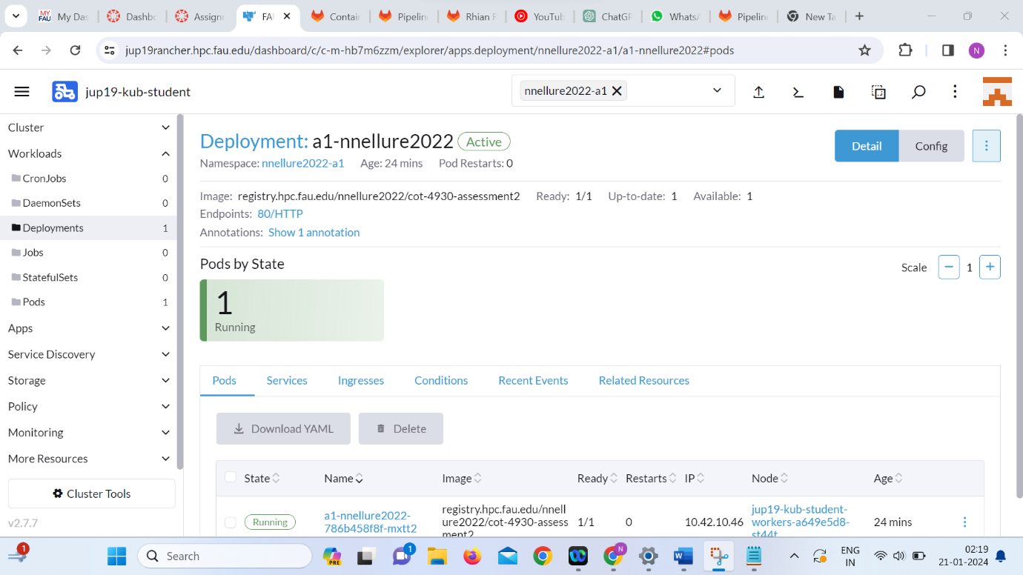

1. Ingress  
   <https://jup19rancher.hpc.fau.edu/dashboard/c/c-m-hb7m6zzm/explorer/networking.k8s.io.ingress>

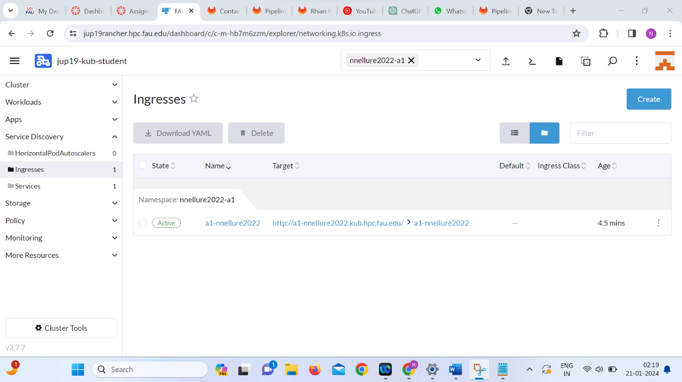

1. Ingress: a1-nnellure2022  
   <https://jup19rancher.hpc.fau.edu/dashboard/c/c-m-hb7m6zzm/explorer/networking.k8s.io.ingress/nnellure2022-a1/a1-nnellure2022#rules>

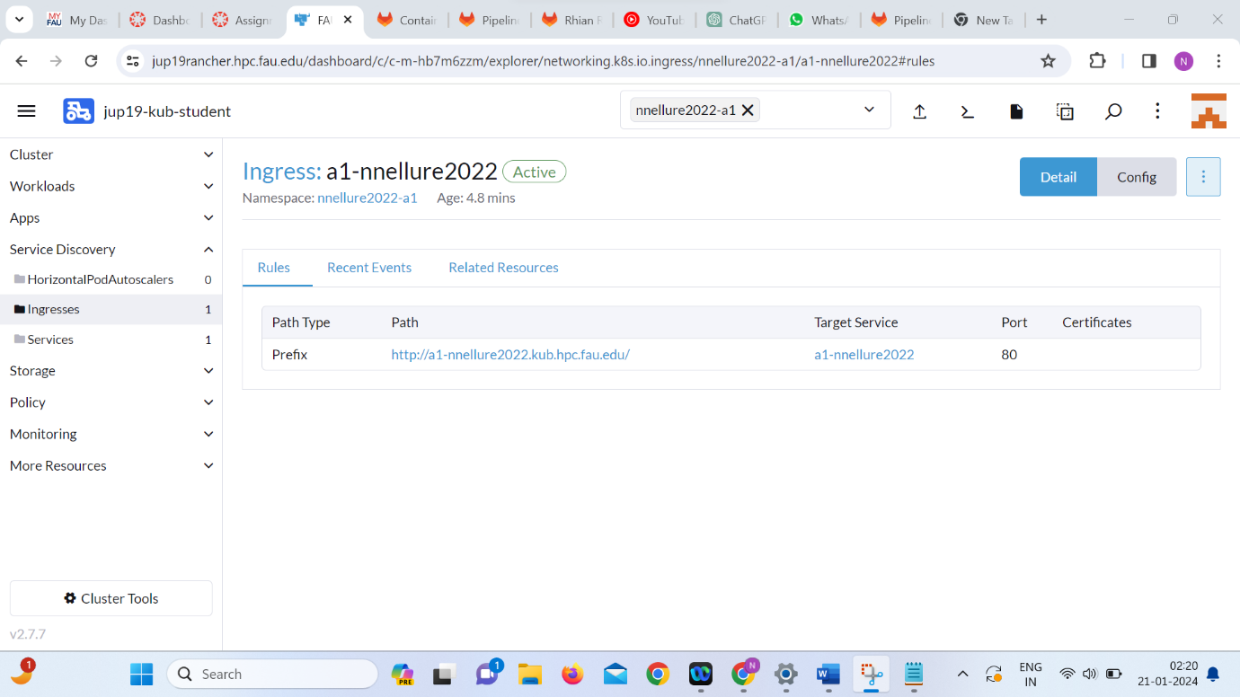

1. Nyan-cat nnellure2022  
   <https://a1-nnellure2022.kub.hpc.fau.edu/>  
     
   